**Hayward Research Project Update Friday 24th May**

1. **Correlating the density measures**

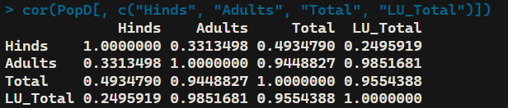

Hind density is weakly correlated with the other density measures.

Hinds+Stags, Hinds+Stags+Calves, and Livestock units are closely correlated to each other, especially Hinds+Stags and Livestock units.

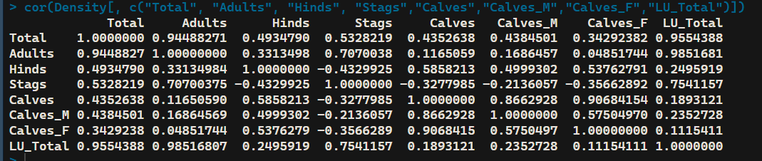

Stag density is negatively correlated to other groups such as Hinds, Calves, Male Calves and Female Calves.

This is in line with the graph I had used for my research project proposal

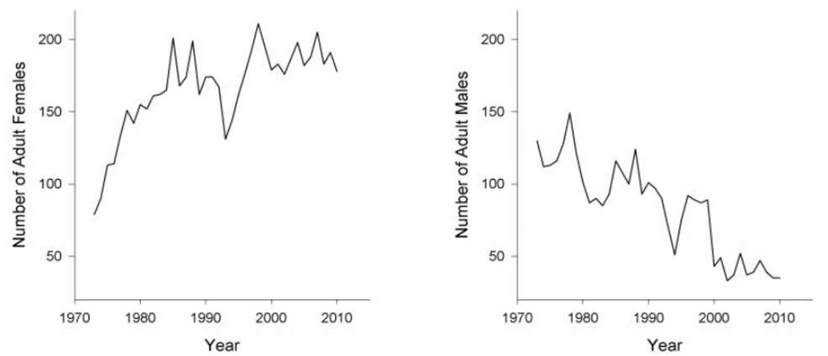

**Fig. 1:** Changes in the number of adult females and males in the study area in Rum

**2&3 Changed to binomial models and using mum age squared**

For example:

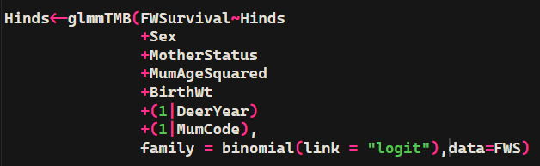

This is my first time using glmmTMB(), I was originally using glmer(), but it's too much for my laptop to handle. I will try to run glmer() on a university computer as they might give different results.

**Results**

**Hinds only**

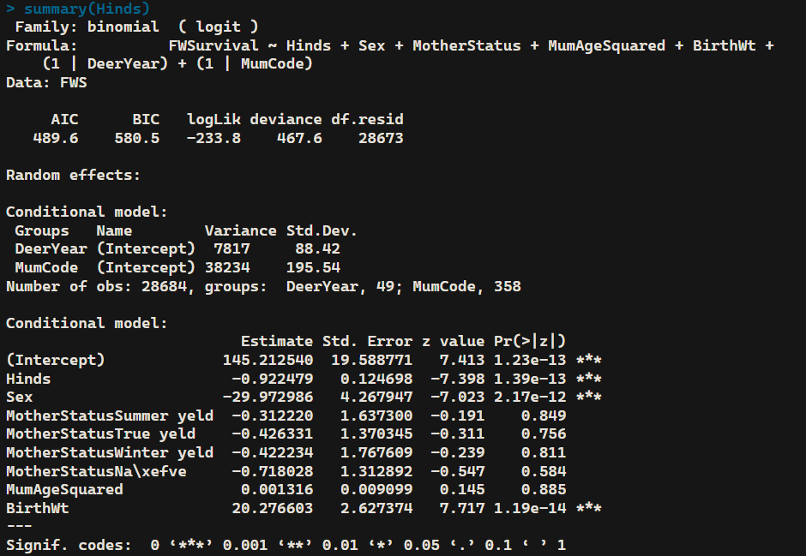

**Hinds+Stags**

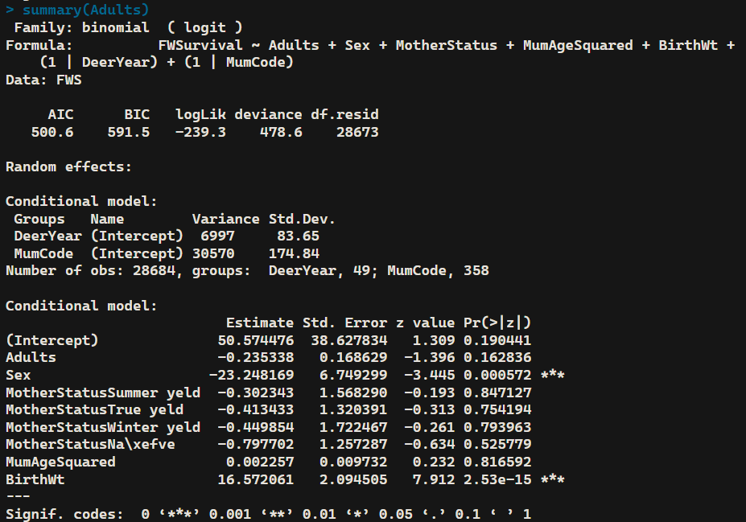

**Hinds+Stags+Calves**

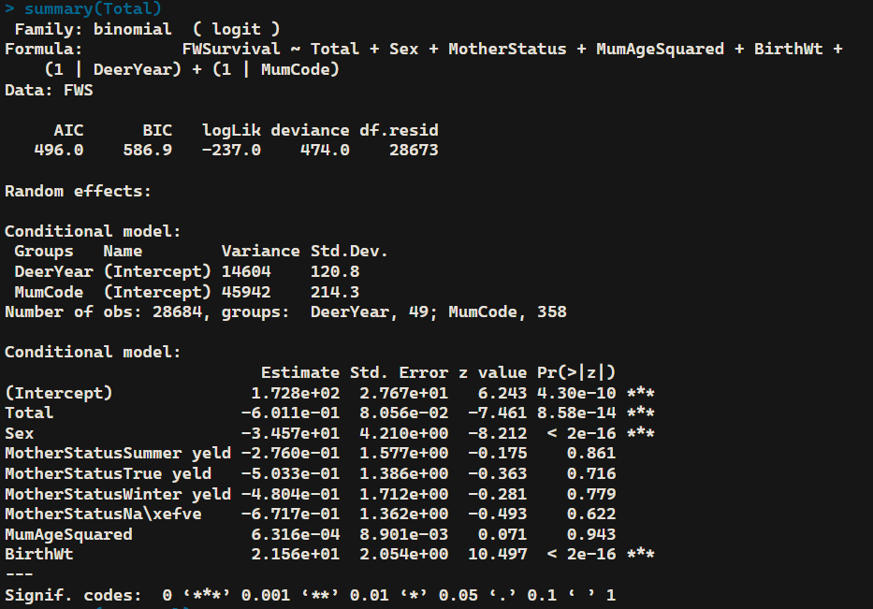

**Livestock units**

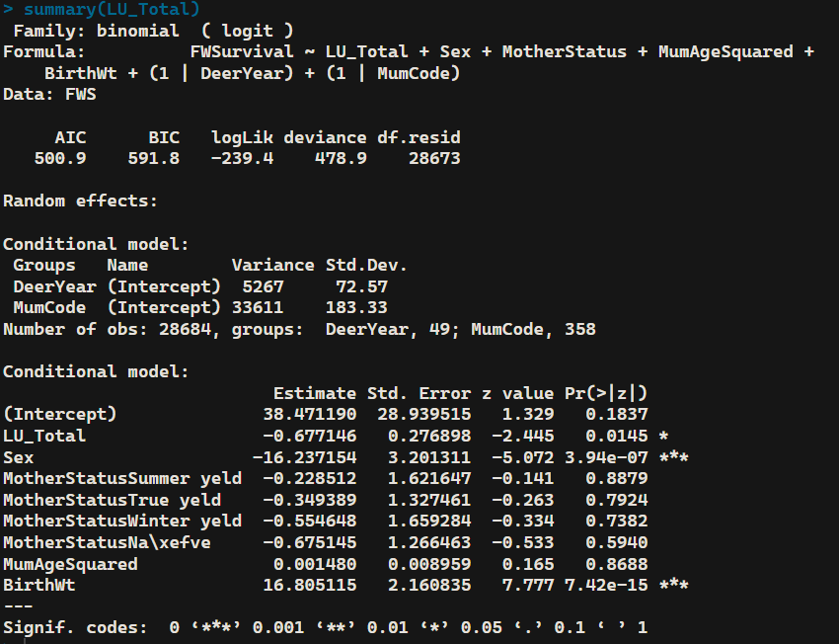

They are showing the right direction now, with negative estimates. However, only the Hinds and Total (Hinds+Stags+Calves) showed strongly significant results. They also started with higher intercepts.

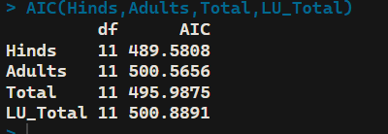

Here are the AIC values of these models, with Hinds still being the most accurate with the lowest AIC value, followed by Total.

**4. Removing Birth Weight**

The results related to Mum status are still negative and insignificant when birth weight was removed. The density measures are now not too significant as well.

**Hinds only without birth weight**

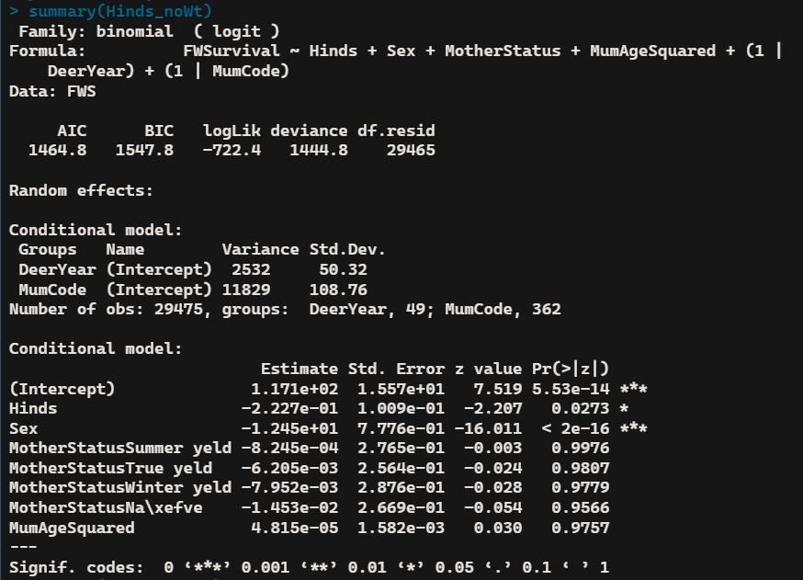

**Hinds+Stags without Birth Weight**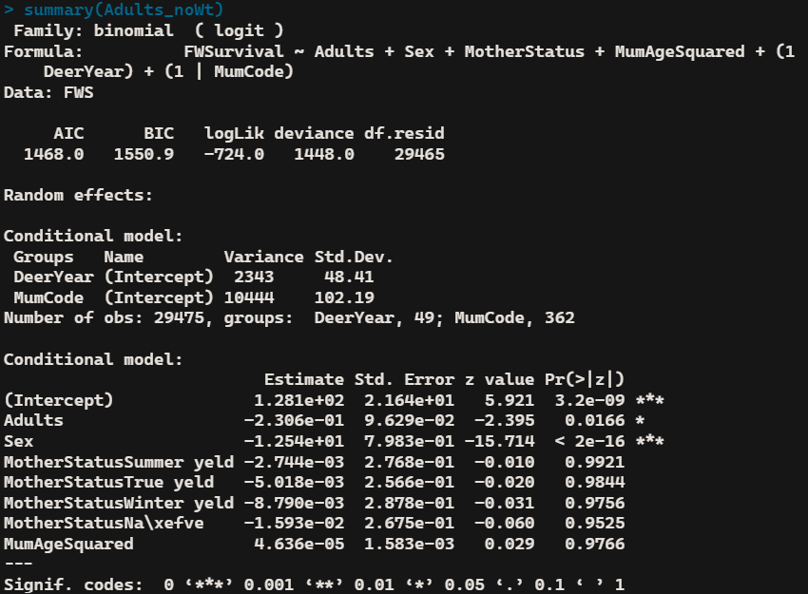

**Hinds+Stags+Calves without Birth Weight**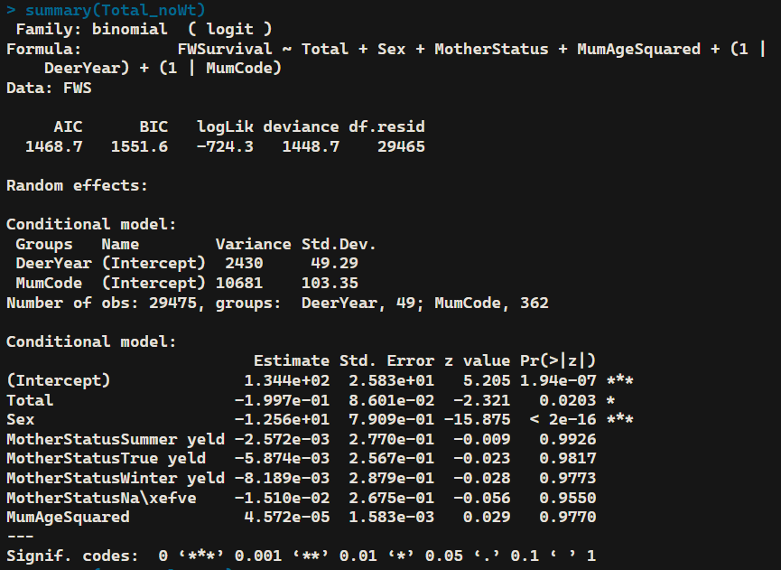

**Livestock Units without Birth Weight**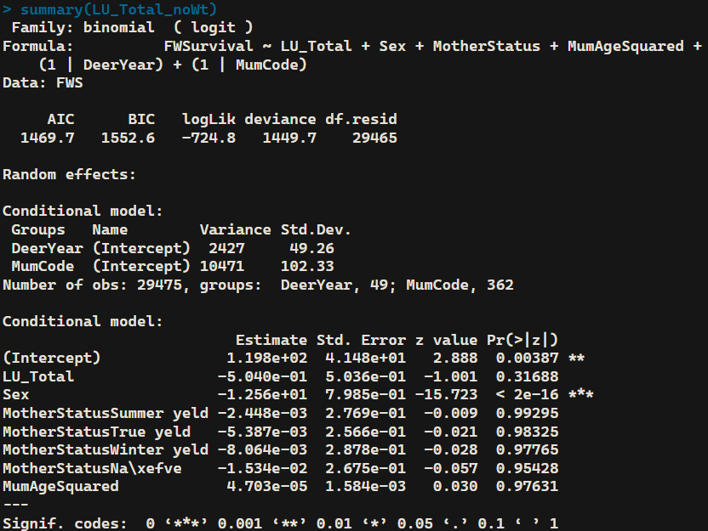

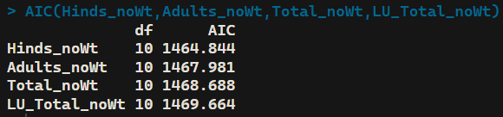

The hinds only model still has the lowest AIC value out of the 4.

**Additional notes**

Since sex is something significant in all of the models above, I tried modelling the first winter survival of males and females as well.

For male FWS, only birthweight for the hinds model was slightly significant, everything else was insignificant.

For female FWS, Birth Weight was highly significant for all models, Hind density was the only density measure that was significant. When I remove birth weight, nothing was significant, not even hind density.